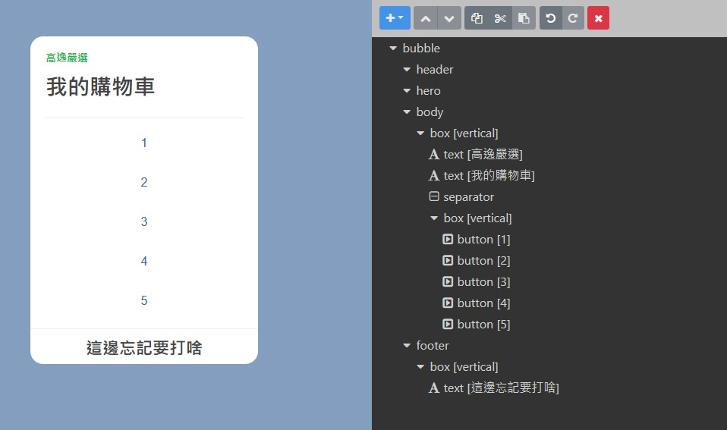
{
"type": "bubble",
"body": {
"type": "box",
"layout": "vertical",
"contents": [
{
"type": "text",
"text": "高逸嚴選",
"weight": "bold",
"color": "#1DB446",
"size": "sm"
},
{
"type": "text",
"text": "我的購物車",
"weight": "bold",
"size": "xxl",
"margin": "md"
},
{
"type": "separator",
"margin": "xxl"
},
{
"type": "box",
"layout": "vertical",
"margin": "md",
"contents": [
{
"type": "button",
"action": {
"type": "message",
"label": "1",
"text": "1"
}
},
{
"type": "button",
"action": {
"type": "message",
"label": "2",
"text": "2"
}
},
{
"type": "button",
"action": {
"type": "message",
"label": "3",
"text": "3"
}
},
{
"type": "button",
"action": {
"type": "message",
"label": "4",
"text": "4"
}
},
{
"type": "button",
"action": {
"type": "message",
"label": "5",
"text": "hello"
}
}
]
}
]
},
"footer": {
"type": "box",
"layout": "vertical",
"contents": [
{
"type": "text",
"text": "這邊忘記要打啥",
"margin": "md",
"size": "xl",
"weight": "bold",
"position": "relative",
"align": "center"
}
],
"spacing": "none",
"paddingAll": "sm"
},
"styles": {
"footer": {
"separator": true
}
}
}

